Version 1.2
User Manual - CCMS
Document History

SL | Date | Version | Description/Changed Area | Make by
1 | 25-Jun-12 | 1.0 | New/Draft | Dewan Ahsanullah
2 | 26-Jun-12 | 1.1 | Reformat | Aminul Bari
3 | 27-Jun-12 | 1.1 | Reviewed | Iftekhar Ahmed
4 | 27-Jun-12 | 1.2 | Changed screen shot in Section 10 and 13 | Dewan Ahsanullah

Contents
Contents 3
1 Overview of CCMS 5
1.1 Citispeed 5
1.2 Citicash 5
1.3 CitiCheck 5
1.4 Normal collection 5
1.5 DD Information 6
2 Hand off File for FlexCube 6
3 Reminder 6
4 Billing 6
5 Work Flow & Data Flow of CCMS 7
6 Input Information 7
6.1 Parameter Input 7
6.2 Primary Input 8
6.3 Process 8
7 Deposit Schedule Information 9
8 Cash Detail Information 9
9 Speed Detail Information 10
10 Check Detail Information 11
11 Collection Information 12
12 DD Information 13
13 Normal Collection Return 14
14 Checking and Booking file for Flexcube: 14
14.1 Booking File 15
14.2 Booking File Authorization 16
14.3 Reversal Entry 16
15 Parameter 19
15.1 Maintain Corr. Bank location 21
15.2 Maintain Branch related information 22
15.3 Maintain Holiday information 23
16 Output (Reports) 24
16.1 Text Report Generation 26

Overview of CCMS
CCMS is developed for Citibank N.A. of Bangladesh. The software is designed to keep tracks of all collection information such as client deposit at different location, generate reminder, maintain billing, DD information and generate handoff file for FlexCube.
CCMS maintain following products:
- CitiSpeed
- CitiCash
- CitiCheck
- NormalCollection.
CCMS capture data which is deposited at different location. Deposit amount are collected on Deposit slip. Amount on deposit maintain in the system.

Citispeed
Citispeed is the product of Citibank which comprises only check information that is collected by coordinator from different location. Customer Check at different location are collected by coordinator and Deposit these checks to Correspondent bank in which Citibank has an account .These checks are honored through clearing house of that location. After getting these check information on deposit slip input are given to CCMS.

Citicash
Citicash is the product of Citibank which keeps track of deposited cash by their customer at different location. System maintains information of Customer cash amount deposit in Correspondent bank at different location which is collected by coordinator.

CitiCheck
Citicheck is the product of Citibank which comprises only check information that is collected by coordinator from different location, under clearing zone. After getting these check information on deposit slip input are given to CCMS. Check deposit at Citibank which is drawn on bank-branches at different location is send to the branches for collection.

Normal collection
Citicheck whether is returned or not, this is to be maintained by normal collection. If returned then what was the reason for returning, system maintains these information through normal collection. CitiCheck drawn on a location which is under clearing house are Normal Collection.

DD Information
CitiCheck which is drawn on a location which is not under clearing house are sent to local bank as DD .This DD information are maintained in the system. Information that has already been given input to CCMS is prepared for CCMS Subsystem for clearing.

Hand off File for FlexCube
A text file contain daily collection amounts are generated from the software for other system like ( FlexCube) to upload which will credit sundry account and debit Corrbank account. This is called booking process .During the file process it checks holiday and prepare data for reversal.
Daily deposit amount pass to Flexcube for booking. It credit Bangladesh bank account and debit sundry account. And prepare data for reversal. Every thousand file generation the filename will be initialized and starts from “7000”.
All the clients must maintain their Cash credit day, check credit day, Cash Credit type, speed Credit type. Get max Seq. no from dschedule. Get Batch no for filename. Generate refno starts from “0000000001”. Prepare credit data. Prepare Booking Data. Separate citicheck amount which value date will be less than todate. And Citicash amount of today. And check holiday and make reversal date of each record. Sort all data according to “cash” and “check” wise. Update refno for each record. Now select all data which are check and prepare data for debit. Prepare debit data for cash it like preparing check. After prepare all data generate booking file. Update reference no in master table.
Another process generates a text file to debit sundry account and credit customer account which is called reversal.

Reminder
Reminder is sent to different bank at different location mentioning the check information which is not sent by those bank within given times. The time is set by the reversal process considering holiday and customer wise predefined time. Reminder generated for different banks to do either of the following: to sent by demand draft payable at Dhaka city or to return the dishonored check immediately.

Billing
End of month bill is prepared for customers regarding services provided by Citibank. Charges are maintained customer wise. As per agreement with customer, Cash and check charges are defined, also it consider return charges, Courier charges, Bangladesh bank charges ,VAT and other charges. Finally a monthly bill is prepared for each customer considering mentioned criteria.

Work Flow & Data Flow of CCMS
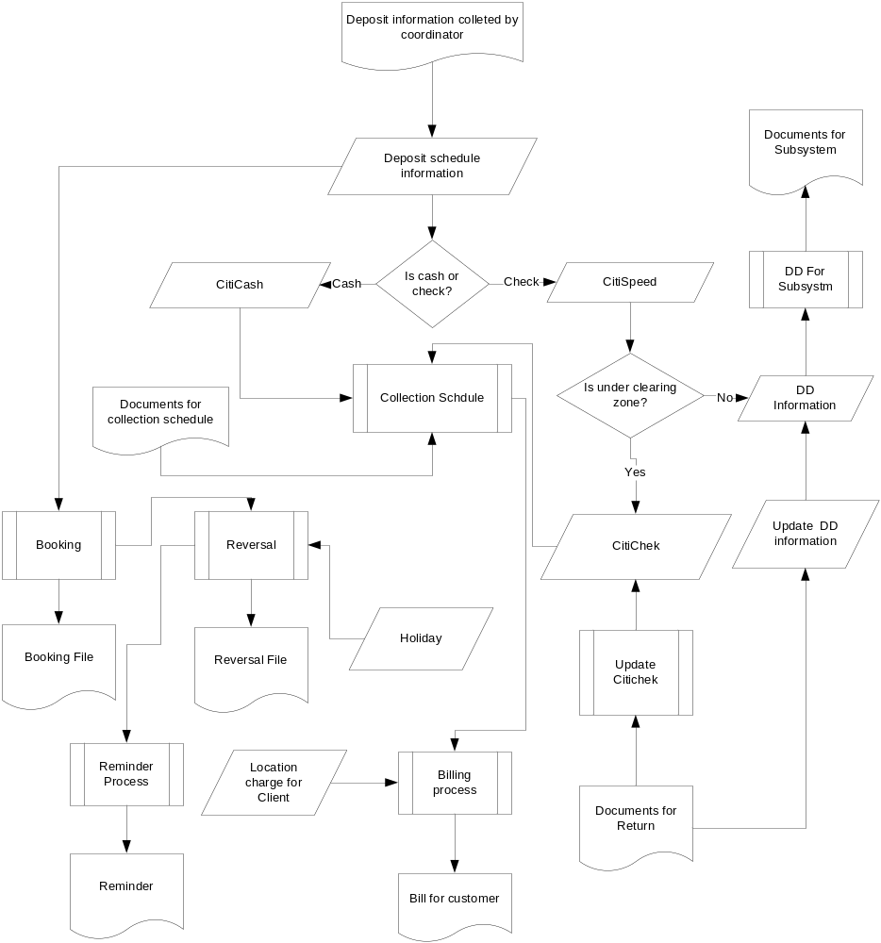

Input Information
The following are the main input information in CCMS

Parameter Input
- Client Information
- Bank Information
- Branch Information
- Correspond Bank Information
- Location Information
- Zone Information
- Reject/Return Information
- Entry Location
- BBK Account Information
- Holiday Information
- Location Charge
- Deposit Schedule Stock

Primary Input
- Deposit Schedule Information
- Cash Detail Information
- Speed Detail Information
- Check Detail Information
- Collection Schedule Information
- DD Detail Information
- Normal Collection Information

Process
- Flex File Generation
- IBBS Booking
- IBBS Reversal
- Billing
- Reminder

Deposit Schedule Information
Deposit information like client code, client name, location code, location name, bank code, bank name which are selected by user. Moreover these users have to put deposit code, deposit date, total check, total check amount, total cash amount. After clicking on save button these information is saved on database for further process. Sequence of Deposit Schedule is given below
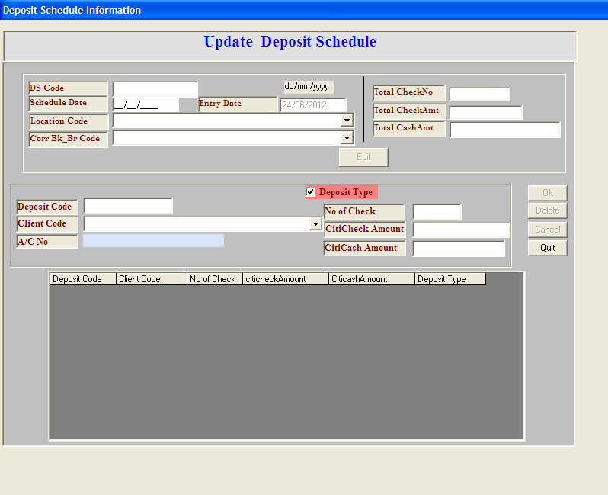
Ok: This button will save the text boxes value into the Bank table.
Delete: It will delete the record that will be given into the Bank Code field.
Clear: This will clear all the text boxes value and temporary displayed element.
Quit: To quiet from the Entry screen

Cash Detail Information
By this form user can update cash detail formation by selecting previously entered data. When he/she put only deposit code then it’s correspond information would be shown like client, location and bank information. Users only have to put slip date, cash reference number and customer reference number. Within clicking on update button this information are updated on database. Sequence of cash detail information is given below:
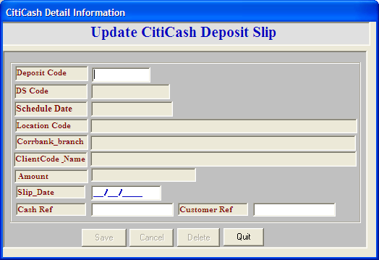
Save: This button will save the text boxes value into the Bank table.
Delete: It will delete the record that will be given into the Bank Code field.
Cancel: This will clear all the text boxes value and temporary displayed element.
Quit: To quiet from the Entry screen
Process: After providing all the information into text boxes, press “Save” button to store into database. Enter a Parameter value into text box and then press Delete button if you want to delete any record from database.
For refreshing page, press Clear button.

Speed Detail Information
Any authorized employee of Citibank can put deposit code into the system and immediately load the information corresponding deposit code. Then user can put slip no, date, drawer bank, branch, total number of check, total check amount and details information regarding individual check like check number, check amount, check reference number and customer reference number. When he/she click on “Ok” button, all information would be saved on database for further processing. Sequence of speed detail Information is given below:
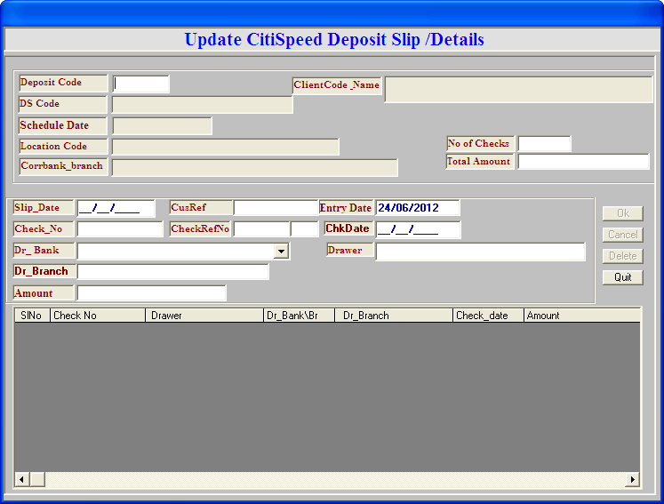
Ok: This button will save the text boxes value into the Bank table.
Delete: It will delete the record that will be given into the Bank Code field.
Cancel: This will clear all the text boxes value and temporary displayed element.
Quit: To quiet from the Entry screen.

Check Detail Information
User can maintain check information using this form. User should put deposit slip no, client no, slips date, value date, deposit location customer reference number, total checks number and total check amount. User also keep track of each check like check drawer, drawee bank, branch, location, clearing zone, check type, check reference number, check number, check date, reject code, check amount.
By clicking on ok button data will be sent to database. The Sequence of the check detail information form is given below:
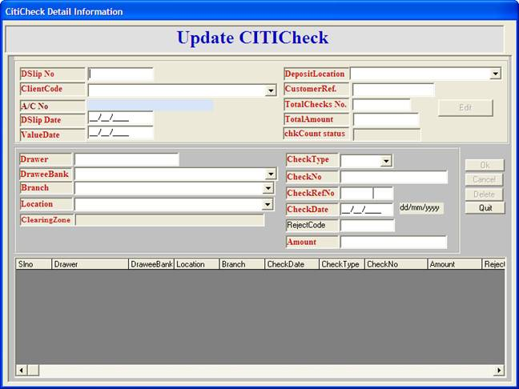

Collection Information
The correspondent will collect the information about check which is already honored or dishonored. With this form user can put information into the system which is very important e.g. collection schedule code, schedule date, location, correspond bank code, deposit schedule code, cash amount, number of check and check amount. The Sequence of this form is given below:
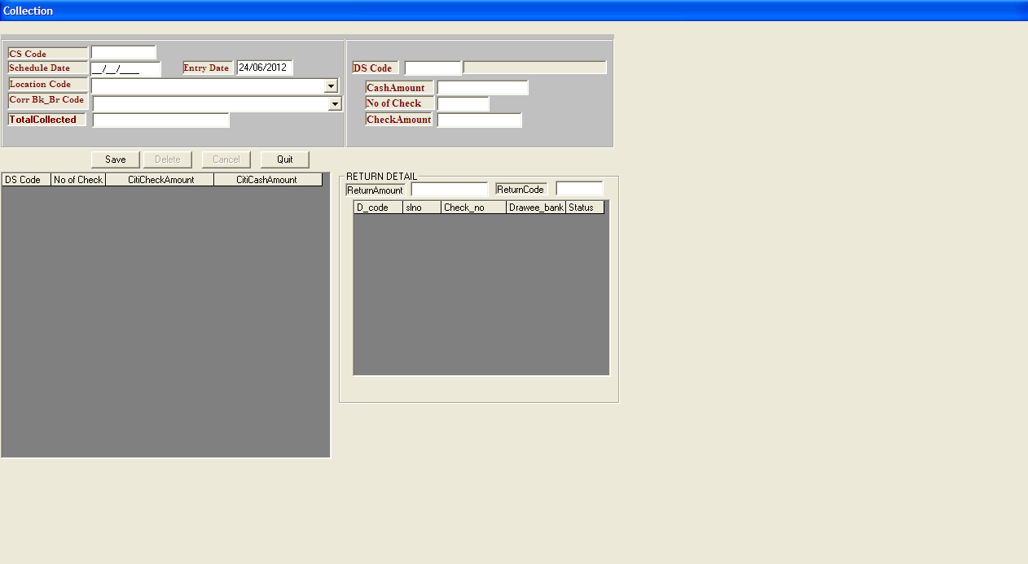

DD Information
User will also enter other necessary information, i.e. deposit code, entry date, DD number, DD date, bank, branch, location, drawee, DD amount. After clicking on “save” button, this information will be saved. Sequence of DD information is given below:
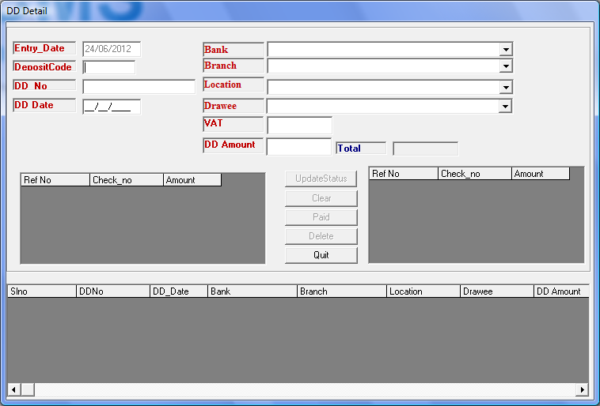

Normal Collection Return
Check status is updated if returned from clearing house. While user enters reference number and check number system automatically return information regarding given reference number and check number. After entering return code when user clicks on update button, check status is updated. Sequence of normal collection return is given below:
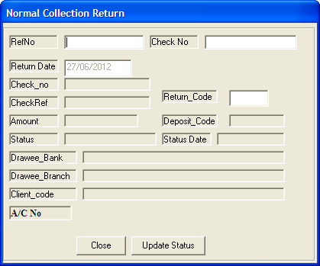

Checking and Booking file for Flexcube:
Daily deposit amount pass to Flexcube for booking. It credits Bangladesh bank account and debit sundry account. And prepare data for reversal. Every thousand file generation the filename will be initialized and starts from “7000”.
All the clients must maintain their Cash credit day, check credit day, Cash Credit type, speed Credit type. Get max Seq. no from dschedule. Get Batch no for filename. Generate refno starts from “0000000001”. Prepare credit data. Prepare Booking Data. Separate citicheck amount which value date will be less than todate. And Citicash amount of today. And check holiday and make reversal date of each record. Sort all data according to “cash” and “check” wise. Update refno for each record. Now select all data which are check and prepare data for debit. Prepare debit data for cash it like preparing check. After prepare all data generate booking file. Update reference no in master table.
Another process generates a text file to debit sundry account and credit customer account which is called reversal.

Booking File
Below are the screens to process the Booking file
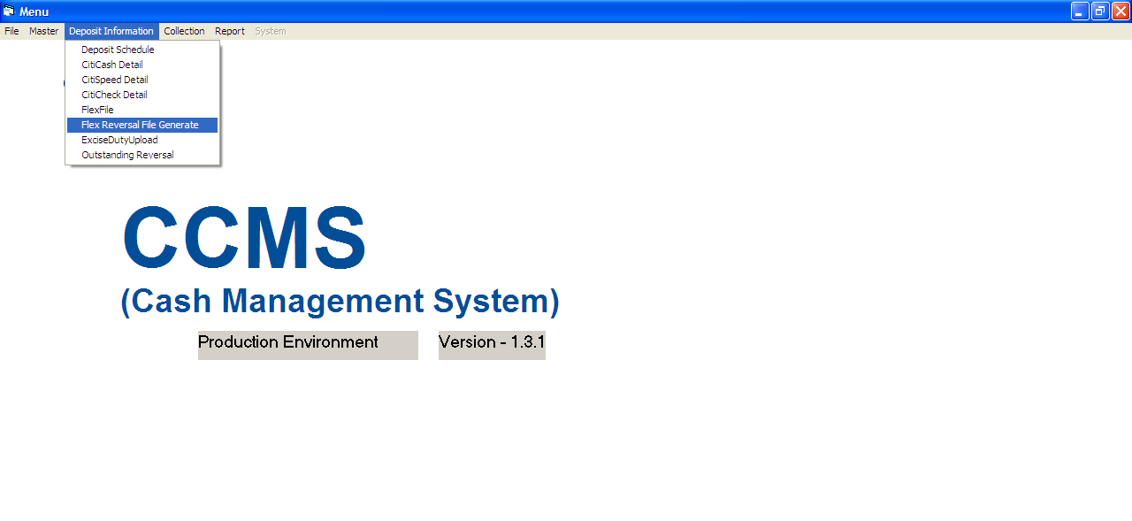

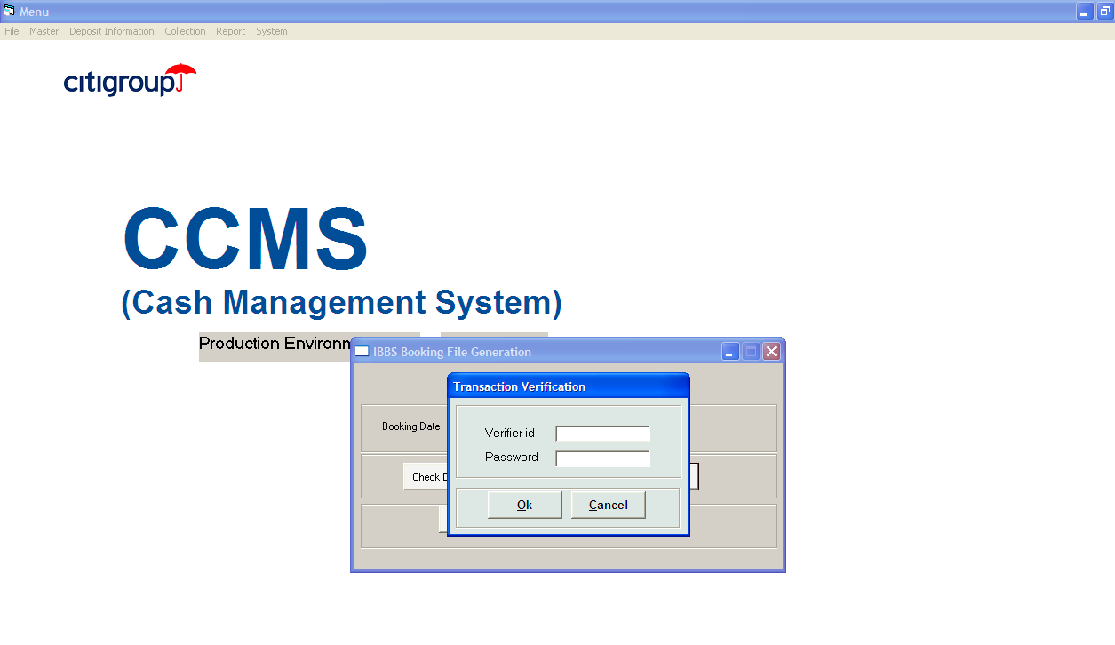

Booking File Authorization
Authorization is required to generate the booking file
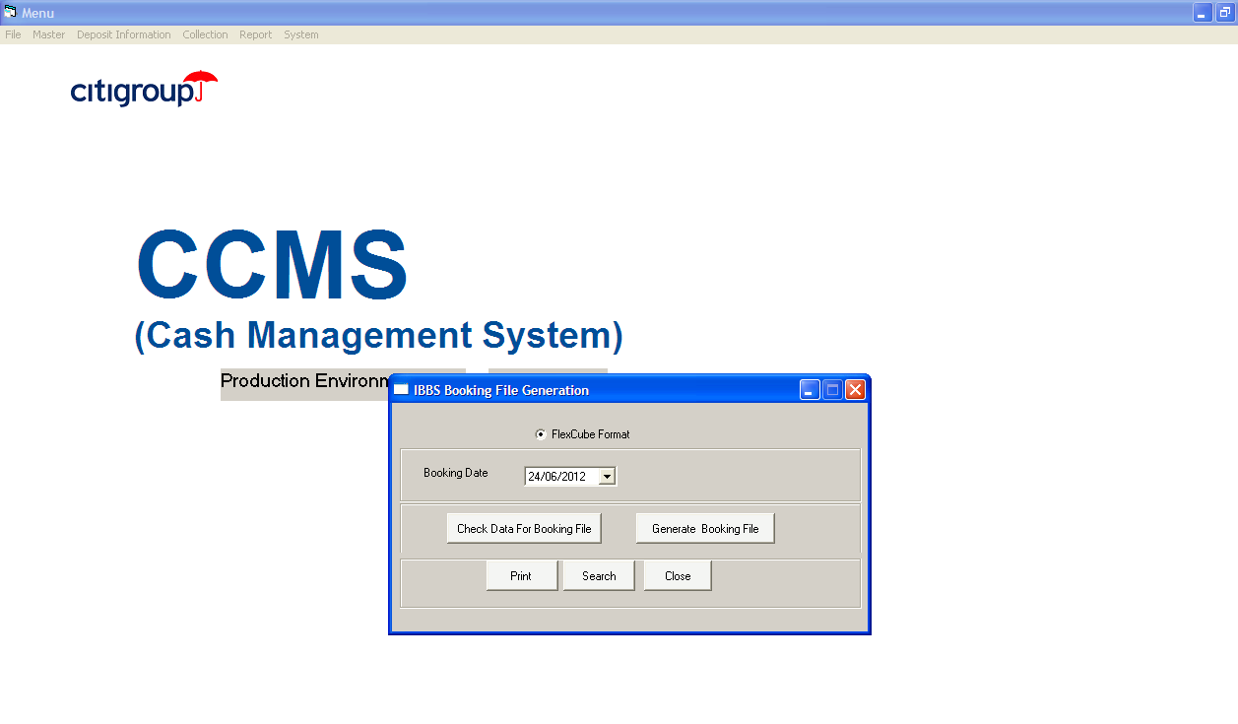

Reversal Entry
After checking file is generated successfully and reconcile with deposit slip .User will generate handoff file for Flexcube for reversal entry.
After successful entry of booking items .User will open reversal screen to generate reversal file.
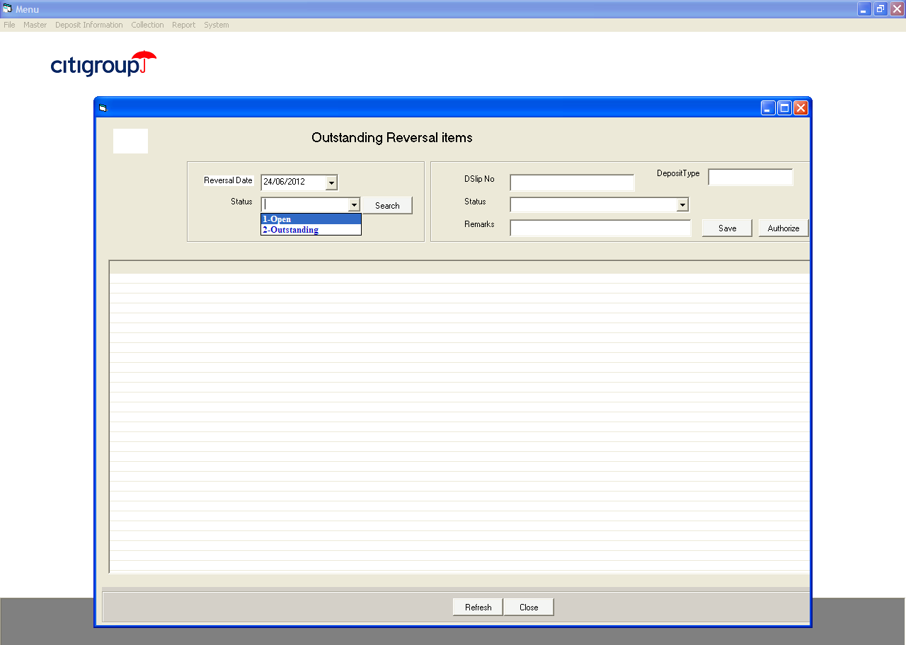

Before generation of Flexcube file Collection schedule is matched with Deposit schedule and shows the outstanding items. After CS entry and DS- CS matching generate Reversal File.

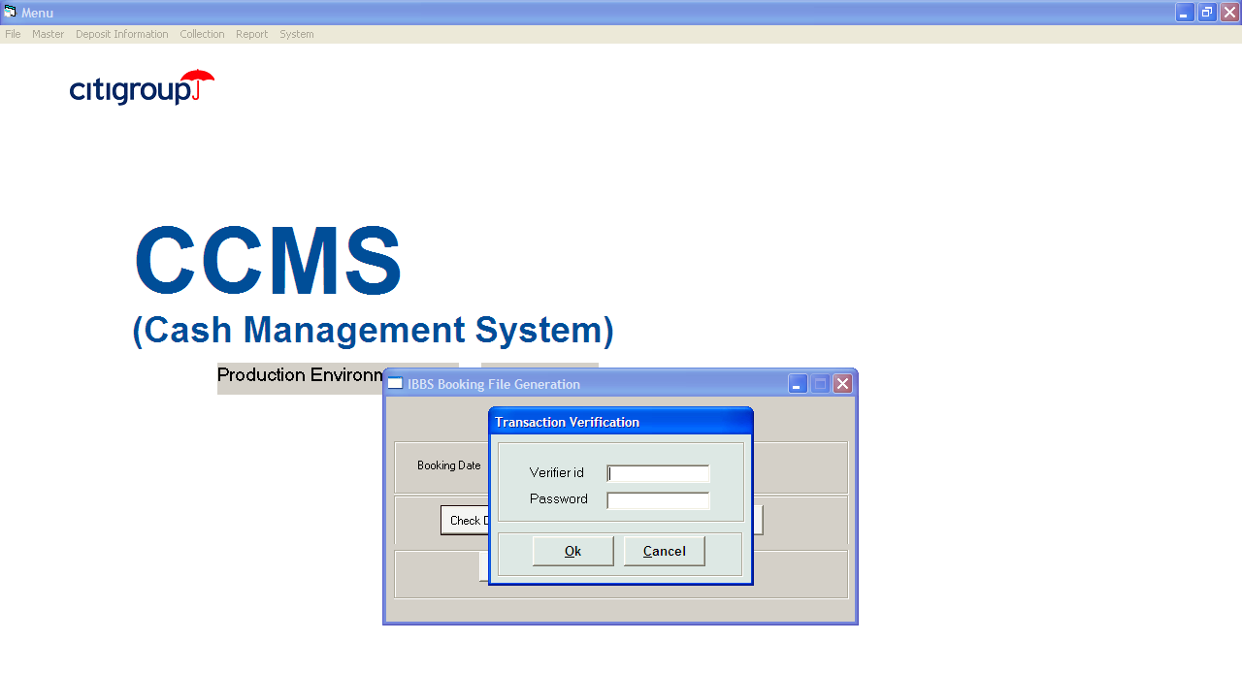

Authorization is required to run the reversal file

Parameter
This Screen is used to client related information
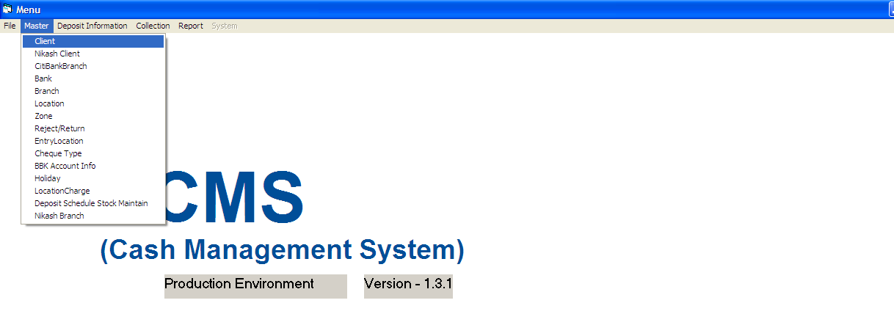

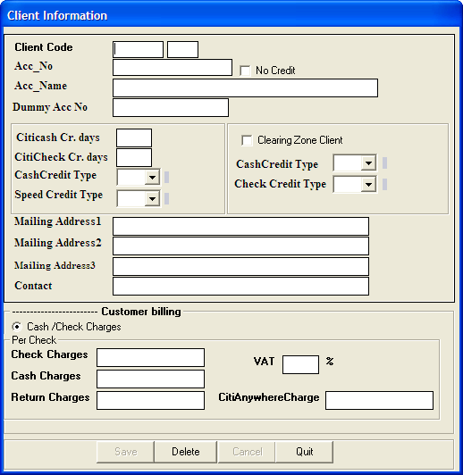
Save: To save data in the database
Delete: It will delete the record that will be given into the Bank Code field.
Cancel: This will clear all the text boxes value and temporary displayed element.
Quit: To quiet from the Entry screen.
Process:
After providing all the information into text boxes, press “Save” button to store into database. Enter a Parameter value into text box and then press Delete button if you want to delete any record from database.
For refreshing page, press Clear button.

Maintain Corr. Bank location

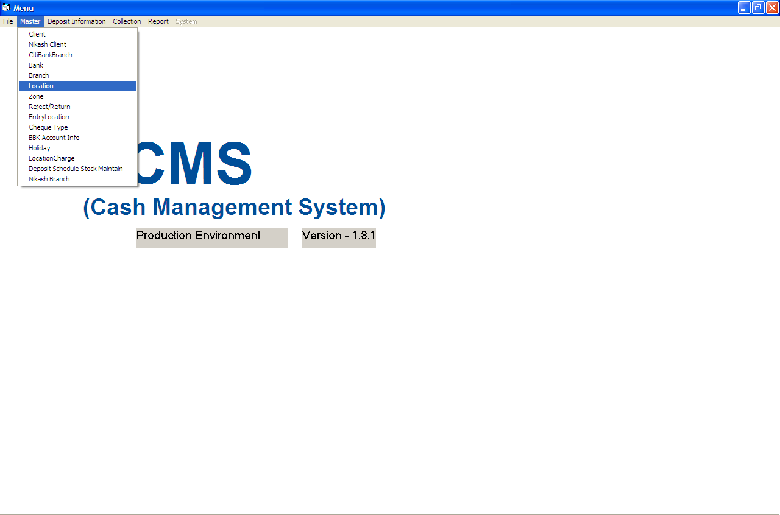
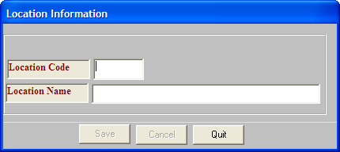

It will maintain Corr. Bank Branch Location
Save: To save data in the database
Delete: It will delete the record that will be given into the Bank Code field.
Cancel: This will clear all the text boxes value and temporary displayed element.
Quit: To quiet from the Entry screen.
Process: After providing all the information into text boxes, press “Save” button to store into database. Enter a Parameter value into text box and then press Delete button if you want to delete any record from database.
For refreshing page, press Clear button.

Maintain Branch related information

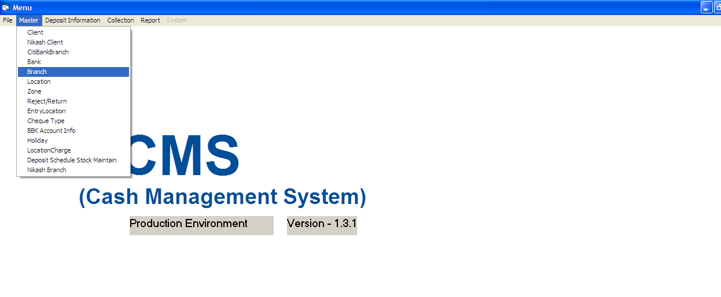

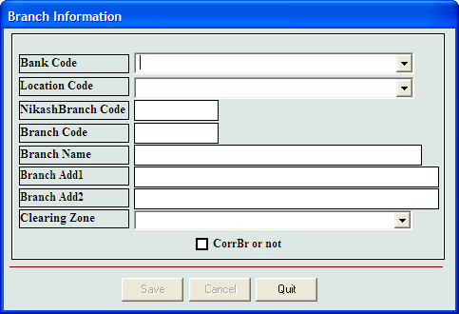
Save: To save data in the database
Cancel: This will clear all the text boxes value and temporary displayed element.
Quit: To quiet from the Entry screen.
Process: After providing all the information into text boxes, press “Save” button to store into database. Enter a Parameter value into text box and then press Delete button if you want to delete any record from database.
For refreshing page, press Cancel button.

Maintain Holiday information

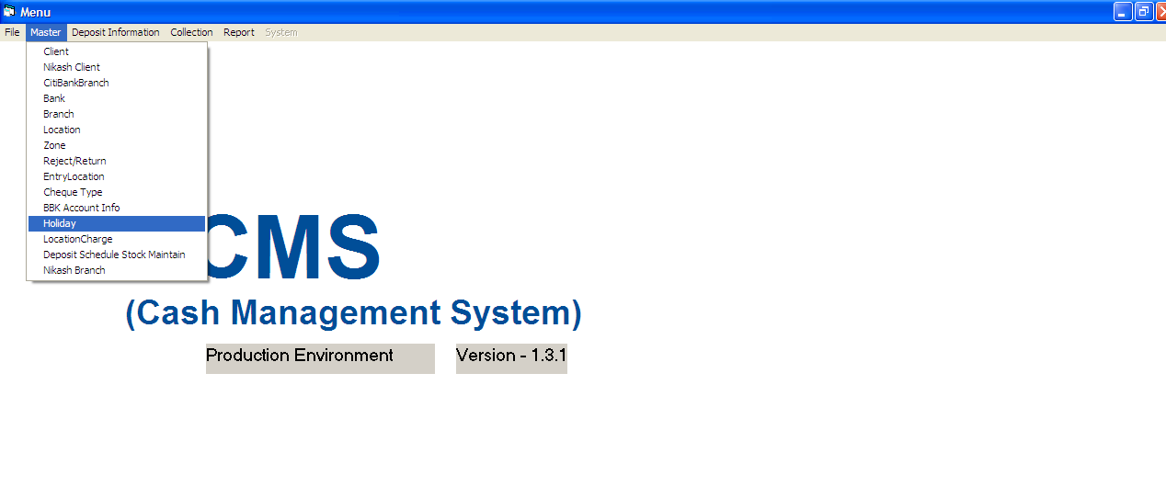

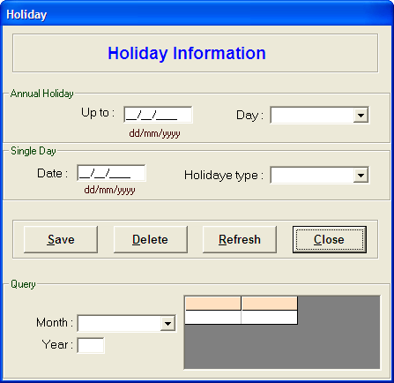
Save: To save data in the database
Delete: To delete record
Refresh: This will clear all the text boxes value and temporary displayed element.
Close: To quiet from the Entry screen.
Process: After providing all the information into text boxes, press ”Save” button to store into database. Enter a Parameter value into text box and then press Delete button if you want to delete any record from database.
For refreshing page, press Refresh button.

Output (Reports)
CCMS has various kinds of MIS reports which are mainly used for daily reconciliation. Below are the names of reports that can be used for daily operations
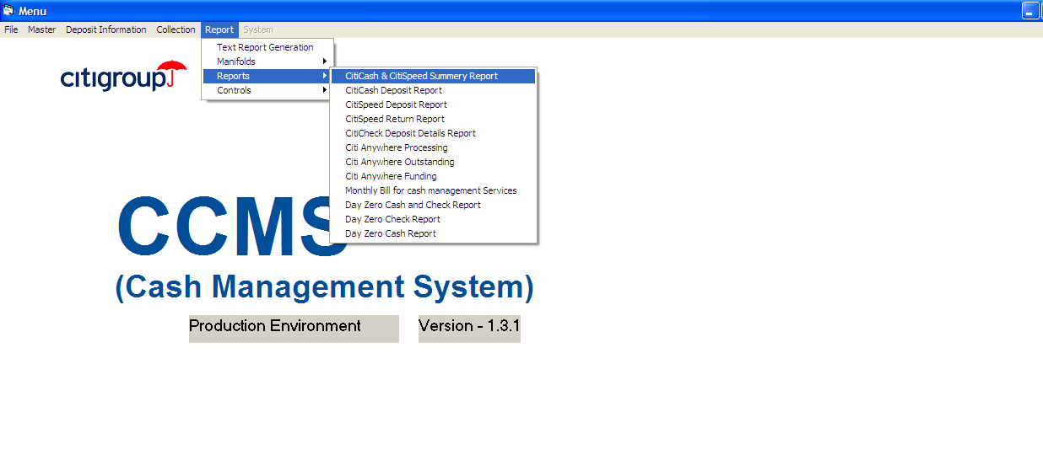
- Reminder
- Monthly Bill
- Check Deposit Manifold
- Check For Collection
- Anywhere Funding
- Check Return Report
- Anywhere Reject
- Anywhere Return
- Cash and Speed Summery Report
- Cash Deposit Report
- Speed Deposit Report
- Speed Return Report
- Check Deposit Details Report
- Anywhere Processing
- Anywhere Funding
- Anywhere Outstanding
- Consolidated Speed Report
- Consolidated Bank Deposit
- Check Manifold Reprint
- Check For Collection Reprint

Text Report Generation
- Speed deposit
- Speed return
- Check deposit
- Cash deposit
- Speed and citicash summery
- Anywhere funding
- Anywhere outstanding

